1.) Website Specifications
Website Objective
African Traditions is a cultural awareness website created to promote Botswana and its rich culture to the rest of the world. The website educates visitors about Botswana's food, dance, tourism, people and way of life. According to Statistics Botswana, over one million tourists visited Botswana in 2023. This shows how important tourism is to the country and why a website that promotes Botswana culture can help attract even more visitors.
Business goals:
The website serves as a platform to attract tourists and promote Botswana as a travel destination. The more people who discover Botswana through this website, the more tourists will visit the country, which benefits the economy. Beyond tourism, the website also helps Botswana connect with people from different countries and build international relations. According to travel research, tourism accounts for 80% of the annual revenue coming into Botswana, which shows just how important it is to promote the country to the rest of the world.
Target Audience:
The website targets tourists and people who are interested in learning about different cultures. The main age group is young adults and older adults aged 18 and above who enjoy exploring and discovering new things.
Website Goal:
The goal is to make people feel that there is more to learn outside of their own cultures. It is meant to inspire visitors to explore, travel and seek new experiences to discover what Botswana has to offer the world.

2.) Information Design & Taxonomy
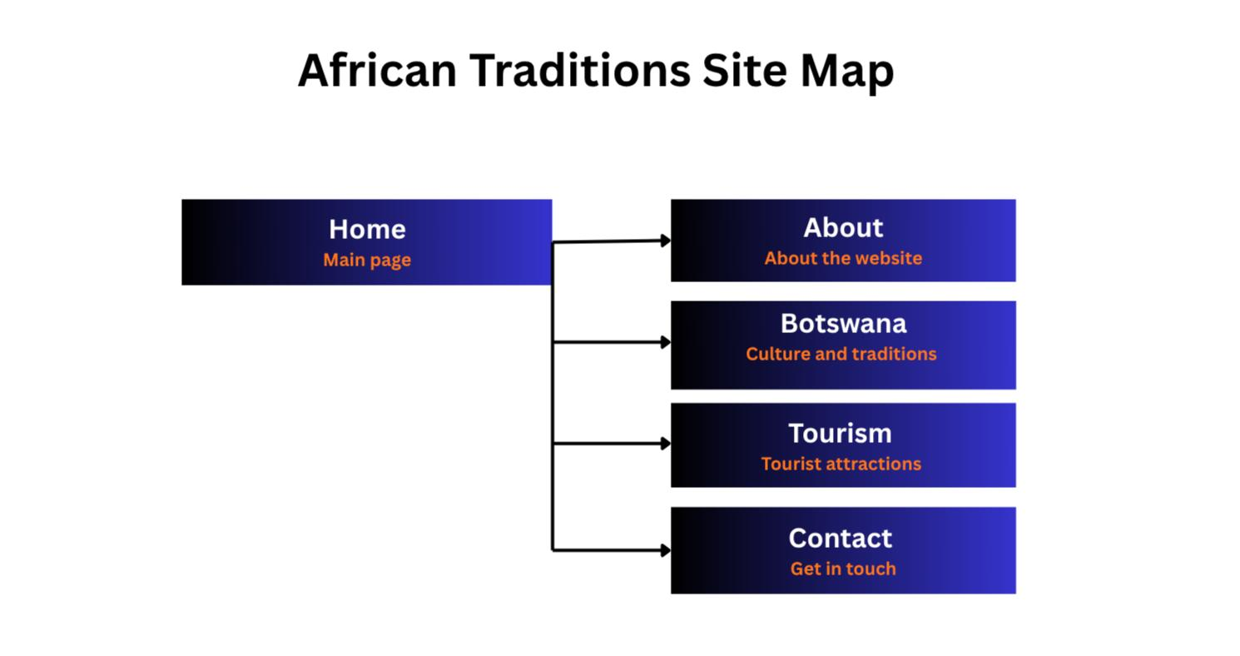
Here is a site map showing all five pages of my website and how they are connected.
3.) Technical brief
VS Code
• Visual Studio Code was used as the main code editor for writing and editing all HTML and CSS files. It also allowed me to run and preview the website locally before pushing changes to GitHub.
HTML5
•HTML5 was used to build the structure of all five pages of the website including the navbar, images, tables and forms.
CSS3
•CSS3 was used to style the website by changing background colours, fonts, text colours and spacing to make the pages look visually appealing.
Bootstrap
• Bootstrap was used to create the navigation bar, cards and a responsive layout that allows the website to display well on both mobile and desktop devices.
GitHub
• GitHub was used to store all website files in a repository and host the live website using GitHub Pages.
Canva
•I used Canva to create the Site Map diagram for the planning and documentation of the website.

